Scientific Notation  Quiz | Name_________________________  Date__________________________

Write each number in standard decimal notation without the use of exponents.
- 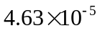 =
- 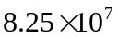 =

Write each number in scientific notation.

- 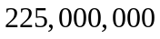 =

- 0.0000000000125 =

Perform the indicated operations. Write the answer in scientific notation.

- 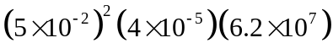=

- 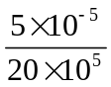=

- 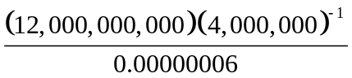 =

- 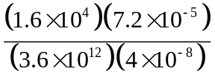 =

SELF-REFLECTION ACTIVITY

- Which segment of Scientific Notations was the most challenging for you?

- What steps are you going to take to learn this subject?

